Preliminary Specification

# HCS12

# Raspberry Pi (Linux Box) - Ovi

The Raspberry Pi 3 model B will be used as the platform link system, it will be running Raspbian a Debian based Linux distribution.

The platform will have some way of identifying the status of the environmental logger through the webcam or metal detector.

It will control the HCS12 board using an RS232 link, and will communicate with the platform supervisor using Wi-Fi.

Hardware specifications:

A 1.2GHz 64-bit quad-core ARMv8 CPU

802.11n Wireless LAN

* Will be used for communicating with the platform supervisor

Bluetooth 4.1

Bluetooth Low Energy (BLE)

1GB RAM

4 USB ports

40 GPIO pins

Full HDMI port

* Useful for debugging purposes so we can see the development environment

Ethernet port

Combined 3.5mm audio jack and composite video

Camera interface (CSI)

* Will investigate this to see if its more viable to use then the camera on the robot

Display interface (DSI)

Micro SD card slot (now push-pull rather than push-push)

* Stores the operating system

VideoCore IV 3D graphics core

# RS-232 – Ovi

RS232 Communication will be used between the COTS system and the platform controller. An external module will need to be added to the raspberry pi 3 so that it can support RS232 communication.

We might need to change the current RS232 communication protocol from last semester so that it can work with an embedded Linux system instead of the platform supervisor running Linux.

RS-232 involves serial communication, communicating one bit at a time at a fast rate. The bits are usually sent in a frame of 8 bits. The speed at which bits are sent is called the baud rate, which is the total number of bits per second.

A general pin layout for RS-232 is as follows:

Pin 1: Data carrier detect

Pin 2: Receives data (this is the pin where information will be sent to)

Pin 3: Transmit data (information will be sent out of this pin)

Pin 4: Data Terminal Ready

Pin 5: Signal Ground

Pin 6: Data set ready

Pin 7: Request to send

Pin 8: Clear to send

Pin 9: Ring indicator

Can use synchronous (program waits for read/write to complete) or asynchronous operations (read/write requests return quickly and program multitasks while waiting)

Operates at voltages of +/- 12 Volts.

# Platform Supervisor (Linux Host)

# PID Control

# Communication Protocol

# Wi-Fi Sensor Monitoring

# Environmental Logger Sensors - Ovi

Thermometric Relative Humidity Sensor

Polymer based relative humidity sensor for humidity monitors and controllers, air conditioners, humidifiers and dehumidifiers, automatic ventilation.

Relevant Electrical Specifications:

Rated Working: Voltage :AC 1 V (50 Hz ~ 1 kHz)

Rated Power: 0.3 mW

Nominal Impedance: 60 kΩ ± 30 kΩ

Typical Humidity Curve

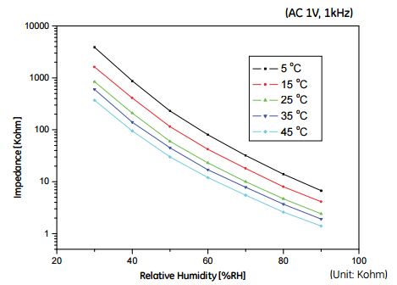

Pressure Sensor

Found most to read 300-1100hPa (4.35-15.95psi)

Most have I2C interfacing andMost come with amplifying circuits

**Barometer with unamplified digital outputs**

[Link to Sensor and Datasheet](http://www.servoflo.com/sensors-by-application/barometric-pressure-measurement-a-compensation/item/463-ms5607.html?utm_source=EMS+Applications+-+July+2013&utm_campaign=EMS-Newsletter&utm_medium=archive)

Requires:

* Voltage stepping with OP-amps
* Logic to convert data into something meaningful

Features:

* Digital outputs
* I2C interfacing and SPI interfacing up to 20MHz

Analog Output Inductive Proximity Sensor (Metal Detector)

Description of how sensor works: Sensor produces an electromagnetic field through oscillation, when metal approaches the field the circuit closes and current flows through the sensor changing the voltage level. This can be integrated with a Schmitt trigger to detect metal.

-fargo controls inc, sensor range: (7.3 – 22mm)

Outputs: 0 – 10V based on the distance between metal and the sensor.

Power supply: 18-30V

size of sensor: (45mm by 55 mm)

<http://www.globalspec.com/pdf/viewpdf?partId>={B16D88EA-D3F4-4880-9C83-047B38030952}&comp=52&from=detail&vid=96420

<http://www.digikey.ca/product-detail/en/panasonic-industrial-automation-sales/GX-F6A/1110-2211-ND/3899739>

Some of the sensors I've found need 12 to 24V, and their sensing distance is a couple mm. This could be incorporated into the project, not sure if we can use the 24V from our board or if we'll need another power supply.

Potential Outline for the report

1. Sensor introduction and description
2. Reason for putting the sensor in the project
3. Sample circuit for signal conditioning
4. Conclusion

# Version Control (GitHub)